
AssureX Claim Engine
AI-Based Warranty Claim Validation System

Project Report & Technical Documentation
Version 1.0

Project | AssureX Claim Engine
Prepared for | TechWiz
Submitted by | Project Team
Technology Stack | Python, FastAPI, MySQL, React, scikit-learn, TensorFlow, PyTorch, Tesseract
Document type | Project Report
Date | September 29, 2026

Table of Contents
- 1. Problem Definition
- 2. Background and Business Necessity
- 3. Proposed Solution
- 4. Purpose of the Document
- 5. Scope of the Project
- 6. Assumptions
- 7. Constraints
- 8. Functional Requirements
- 9. Non-Functional Requirements
- 10. Application Architecture
- 11. Module Descriptions
- 12. Database Design
- 13. Data Dictionary
- 14. Data Flow Diagram
- 15. Use Case Diagram
- 16. Activity Diagram
- 17. Sequence Diagram
- 18. Decision Flow Diagram
- 19. Rule-Engine Design
- 20. Python Classification Model Design
- 21. Google Teachable Machine Model Design
- 22. Dataset Description
- 23. Dataset-Generation Method
- 24. Data Preprocessing and Feature Engineering
- 25. Python Model-Training Procedure
- 26. Google Teachable Machine Training Procedure
- 27. Model Evaluation
- 28. Confusion Matrix
- 29. Accuracy, Precision, Recall and F1-Score
- 30. Model Prediction and Confidence Comparison
- 31. Testing Strategy
- 32. Security Considerations
- 33. Privacy Considerations
- 34. Limitations
- 35. Future Enhancements

1. Problem Definition
Warranty claim processing is a high-volume, fraud-prone activity in the consumer electronics and appliance industry. A claim is valid only when the product is within its warranty period, the reported fault is covered by the warranty policy, the supporting documents are authentic and internally consistent, and the claim has not already been submitted. Manually verifying these conditions is slow, costly and inconsistent. The problem this project addresses is the absence of an automated, explainable and auditable system that can ingest a claim with its documents, extract and verify the data, evaluate it against warranty rules and machine-learning models, and produce a reliable decision that separates clear approvals, clear rejections and cases that genuinely require human judgement.

2. Background and Business Necessity
Traditional systems perform only a simple date check against the warranty period. They cannot read a photographed receipt, compare a serial number, detect contradictory dates, or recognise duplicate submissions. As a result, support teams spend most of their time on repetitive verification, genuine customers wait days for a decision, and fraudulent claims slip through. Businesses therefore need an intelligent layer that reads documents automatically, learns patterns of valid and invalid claims, and remains transparent enough to be audited. The necessity is both operational (reduce manual workload and turnaround time) and financial (prevent wrongful payouts while protecting honest customers).

3. Proposed Solution
The AssureX Claim Engine is an end-to-end web application that automates warranty claim validation. Customers register products and warranties, file claims and upload documents. The system extracts data from receipts and warranty cards using OCR and QR decoding, verifies the extracted values, and then runs a dual-model evaluation. A Python tabular classifier scores structured claim features, while a Google Teachable Machine image classifier scores a standardised Claim Summary Card rendered from the same facts. The two predictions and their confidence scores are compared, and a configurable rule engine checks warranty coverage, missing documents, contradictions and duplicates. The combined result is exactly one of Likely Valid, Likely Invalid or Manual Review Required, with a full explanation and an audit trail. Ambiguous claims are routed to a reviewer who can override the recommendation.

4. Purpose of the Document
This document is the project report and technical documentation for the AssureX Claim Engine. It describes the problem, the proposed solution, the scope, the requirements, the architecture, the database design, the diagrams, the machine-learning design, the dataset, the model training and evaluation, the testing strategy, and the security, privacy, limitations and future work. It is intended for the evaluating faculty, the development team and any future maintainer who needs to understand or extend the system.

5. Scope of the Project
The scope covers the complete claim lifecycle: user registration and authentication with role-based access control; product and warranty registration; claim creation through a guided wizard; document upload with hashing; OCR and QR extraction; extracted-data verification; data preprocessing and feature engineering; dual-model classification; model and confidence comparison; warranty-rule evaluation; missing-document, contradiction and duplicate detection; manual review and reviewer override with audit logging; administrator dashboards and analytics; notifications and warranty-expiry alerts; and CSV report export. The system is delivered as a FastAPI backend, a React frontend, a MySQL database and a machine-learning service. Out of scope are real payment processing, integration with external ERP or CRM systems, and training on real (non-synthetic) customer data.

6. Assumptions
- Users upload genuine, legible documents; OCR accuracy depends on image quality.
- The registered product record (serial number, purchase date, price, retailer) is treated as the source of truth.
- Warranty policies per product category are maintained as JSON configuration files.
- The system is deployed on a single server with a CPU-only inference environment for the demonstration.
- The synthetic dataset used for training faithfully represents the distributions of the real domain.
- Reviewers are trained staff who can interpret the model explanations and rule findings.

7. Constraints
- CPU-only training and inference limited the size of the image model that could be trained within the schedule.
- No public warranty-claim dataset was available, so a synthetic dataset had to be generated.
- OCR accuracy is bounded by the quality of the uploaded images and by Tesseract's limitations.
- Uploaded file size is capped at 10 MB and only certain file types are accepted.
- The database is MySQL, so JSON fields and enums follow MySQL semantics.
- The demonstration must run locally with MySQL/XAMPP and a fixed frontend port (5174).

8. Functional Requirements
The functional requirements are identified as FR-001 to FR-061 in the functional requirements document. A representative subset is summarised below; each requirement maps to a stable identifier used for traceability against the implementation and tests.
ID | Requirement | Priority
FR-001 | User registration and login for four roles | MUST
FR-002 | Role-based access control on all routes and records | MUST
FR-005 | Product registration with serial number and purchase details | MUST
FR-007 | Warranty record storage (standard and extended) | MUST
FR-009 | Automatic warranty expiry and remaining-period calculation | MUST
FR-014 | OCR extraction of receipt and invoice fields | MUST
FR-015 | Display extracted data and allow correction before submission | MUST
FR-016 | Claim registration with a unique claim ID | MUST
FR-019 | Fault and damage evidence upload | MUST
FR-024 | Common dataset for both models (CSV + summary cards) | MUST
FR-026 | Python classification model (Valid / Invalid / Manual Review) | MUST
FR-027 | Confidence scores for all three classes | MUST
FR-028 | Automatic Claim Summary Card generation (no model-output leakage) | MUST
FR-029 | Google Teachable Machine image classification | MUST
FR-030 | Comparison of the two model predictions | MUST
FR-031 | Confidence-score comparison and difference | MUST
FR-032 | Configurable model-consistency status | MUST
FR-033 | Warranty rule validation | MUST
FR-035 | Serial-number verification against documents | MUST
FR-036 | Contradiction detection | MUST
FR-037 | Missing-document detection | MUST
FR-038 | Duplicate-claim detection | MUST
FR-039 | Document duplicate detection using hashing | MUST
FR-042 | Final decision: Likely Valid / Likely Invalid / Manual Review Required | MUST
FR-043 | Decision explanation (supporting/opposing/rules) | MUST
FR-044 | Manual review queue | MUST
FR-046 | Reviewer comments and override with audit history | MUST
FR-050 | Administrator dashboard and analytics | MUST
FR-054 | Data export in CSV format | SHOULD
FR-057 | Model version tracking per prediction | MUST

9. Non-Functional Requirements
Area | Requirement
Performance | Claim evaluation completes in a few seconds; models are loaded once and cached at start-up.
Scalability | Stateless API with a relational database; horizontal scaling possible behind a load balancer.
Security | Passwords hashed (pbkdf2_sha256); JWT (HS256) with expiry; role-based access control.
Reliability | Global exception handling returns safe messages; audit logging for every critical action.
Maintainability | Clear separation of routes, rules, OCR, services and ML; configurable thresholds and policies.
Usability | Responsive React interface with a guided five-step claim wizard and plain-language labels.
Portability | Runs on Windows/Linux with Python 3.10+, MySQL 8 and Node.js 18+.
Explainability | Every decision includes supporting/opposing factors and the rules that passed or failed.
Auditability | Immutable audit trail of submissions, evaluations, uploads and reviewer overrides.

10. Application Architecture
The system uses a layered architecture. The presentation tier is a React single-page application built with Vite and Bootstrap. The API tier is a FastAPI application exposing REST endpoints and enforcing JWT authentication and role-based access control. The service tier contains the rules engine, the contradiction checker, the duplicate detector, notifications and monitoring. The ML service contains the decision engine, the Python tabular model, the Teachable Machine image model and the summary-card renderer. The OCR layer uses Tesseract and OpenCV. The data tier is MySQL accessed through SQLAlchemy, with uploaded files stored on disk.
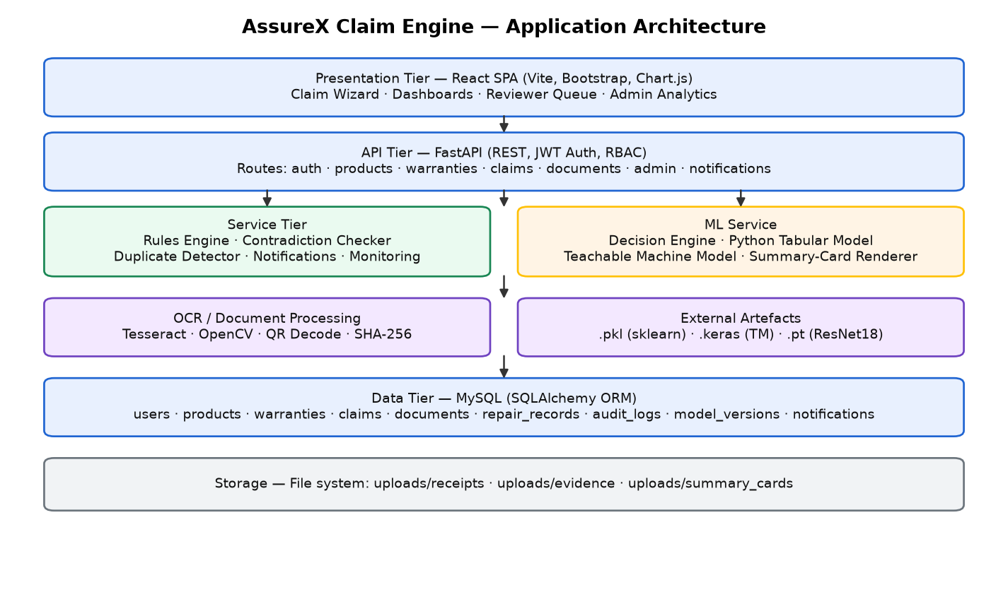
Architecture

11. Module Descriptions
Module | Responsibility
backend/routes | Auth, products, warranties, claims, documents, admin, notifications endpoints.
backend/database | SQLAlchemy models, connection and database initialisation/seeding.
backend/rules | rule_engine, contradiction_checker, duplicate_detector.
backend/ocr | document_parser: Tesseract OCR, OpenCV preprocessing, QR decode, SHA-256 hashing, field extraction.
backend/services | Notifications, monitoring/anomaly checks, warranty expiry alerts.
backend/middleware | JWT authentication and role-based access control dependencies.
ml_service | decision_engine, python_classifier, gtm_classifier, tm_classifier, training scripts.
dataset_generator | Synthetic claim generation, splitting, summary-card rendering and validation.
frontend/src | React pages (dashboard, products, warranties, claim wizard, claim detail, reviewer queue, admin), components and API client.
config | settings.py and settings.json (thresholds, paths, expiry alert days).
policies | Per-category warranty policy JSON files.

12. Database Design
The database is normalised into nine tables. Users own products and claims; each product has one warranty; each claim links a user, a product and a warranty, and has many documents, repair records and audit-log entries. Model versions record the exact model artefacts used, and notifications store user alerts.
The physical database schema diagram below lists every table with its columns and marks the primary keys (PK), foreign keys (FK) and unique columns (UQ).
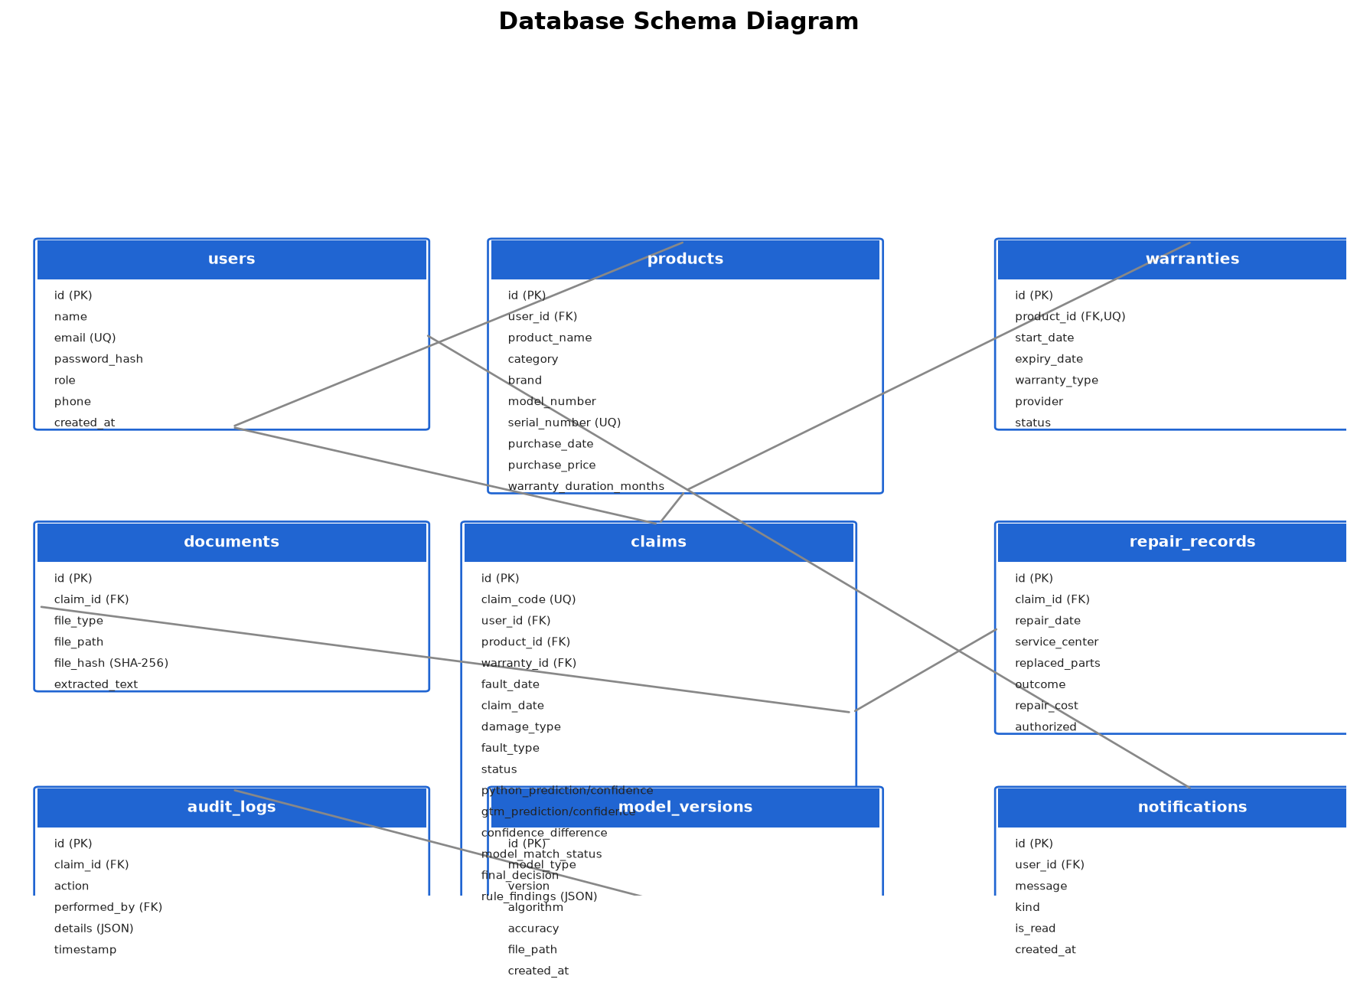
Database Diagram
The entity-relationship diagram (ERD) below shows the entities and the cardinality of the relationships between them (one-to-one, one-to-many).
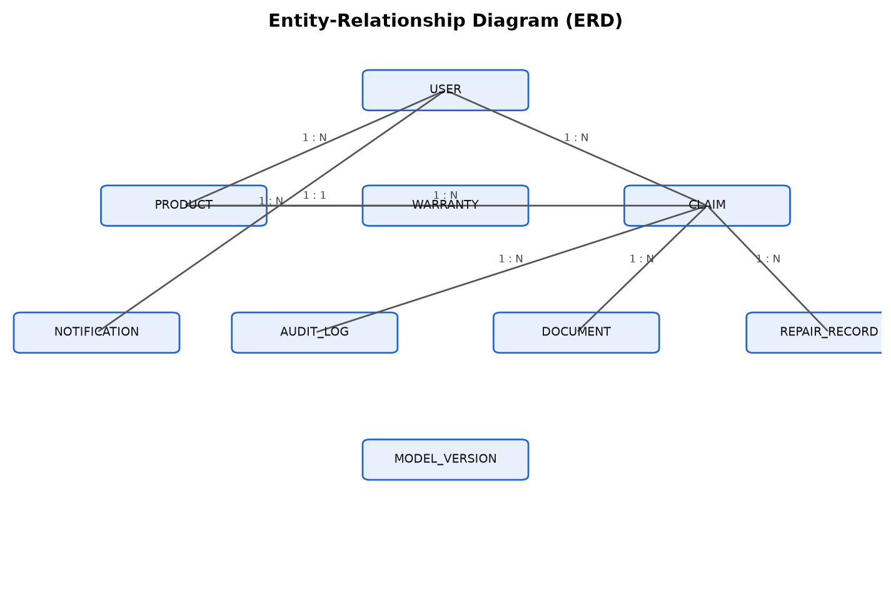
Erd
Table | Purpose | Key columns
users | Registered accounts | id, email (unique), password_hash, role
products | Registered products | id, user_id, serial_number (unique), category
warranties | Warranty per product | id, product_id (unique), start_date, expiry_date, status
claims | Warranty claims | id, claim_code, user_id, product_id, status, predictions
documents | Uploaded files | id, claim_id, file_type, file_hash
repair_records | Past repairs | id, claim_id, repair_date, authorized
audit_logs | Action history | id, claim_id, action, performed_by, details
model_versions | Model registry | id, model_type, version, accuracy, file_path
notifications | User alerts | id, user_id, message, kind, is_read

13. Data Dictionary
A representative data dictionary for the core entities follows.
Table | Field | Type | Description
users | id | INT PK | Unique user identifier
users | email | VARCHAR(255) | Login email (unique)
users | password_hash | VARCHAR(255) | Hashed password (pbkdf2_sha256)
users | role | ENUM | customer / service_center / reviewer / admin
products | serial_number | VARCHAR(120) | Unique serial used for document matching
products | purchase_date | DATE | Date of purchase
products | purchase_price | FLOAT | Purchase amount
products | warranty_duration_months | INT | Warranty length in months
warranties | expiry_date | DATE | Computed warranty expiry
warranties | status | ENUM | active / expired / nearing_expiry
claims | claim_code | VARCHAR(32) | Human-readable claim ID (CLAIM-00001)
claims | damage_type | VARCHAR(80) | Reported damage category
claims | fault_type | VARCHAR(80) | Fault classification
claims | python_prediction | VARCHAR(32) | Tabular model prediction
claims | python_confidence | FLOAT | Tabular model confidence
claims | gtm_prediction | VARCHAR(32) | Image model prediction
claims | gtm_confidence | FLOAT | Image model confidence
claims | confidence_difference | FLOAT | Absolute difference of confidences
claims | model_match_status | VARCHAR(40) | Strong/Acceptable/Weak/Disagreement/Uncertain
claims | final_decision | VARCHAR(40) | Likely Valid / Likely Invalid / Manual Review Required
claims | rule_findings | JSON | Rule, contradiction and duplicate findings
documents | file_type | ENUM | receipt / warranty_card / damage_photo / serial_photo / ...
documents | file_hash | VARCHAR(64) | SHA-256 hash for duplicate detection
documents | extracted_text | TEXT | OCR + QR text
audit_logs | action | VARCHAR(80) | Action name (e.g. dual_model_evaluation)
model_versions | accuracy | FLOAT | Reported test accuracy of the version

14. Data Flow Diagram
The level-1 data flow diagram shows the external actors, the main processes and the data stores. Documents flow into process 3.0 for OCR, the extracted fields and rule findings flow into process 5.0 for dual-model evaluation, and the result is written to the claims and audit stores.
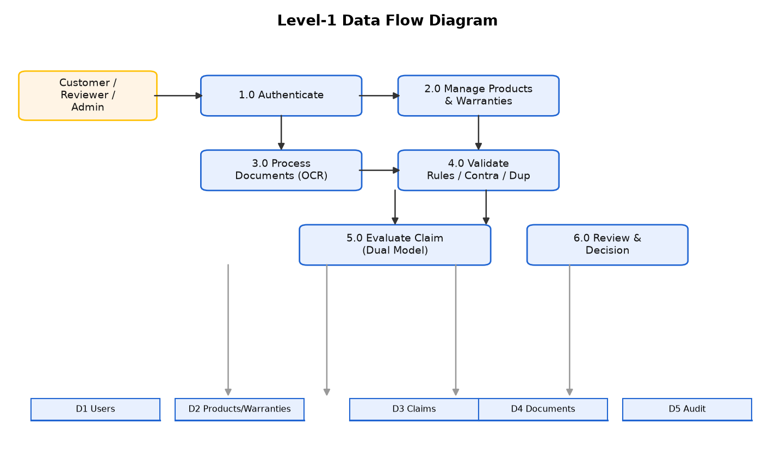
Dfd
The end-to-end process flow diagram below summarises the complete claim journey from login to the final model comparison, showing where OCR, preprocessing, rule checks and the two models run.
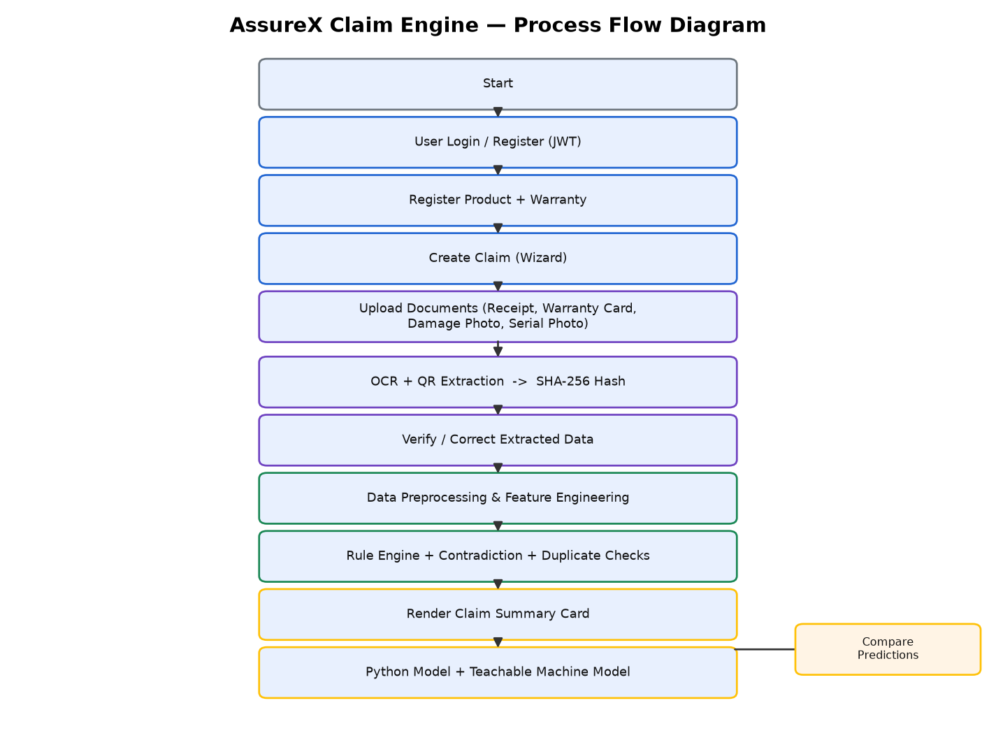
Flow Diagram

15. Use Case Diagram
The use case diagram shows the four actors and the functions each can perform. Customers and service-centre staff register products, file claims and upload documents; reviewers handle the manual-review queue and overrides; administrators see the full dashboard and export reports.
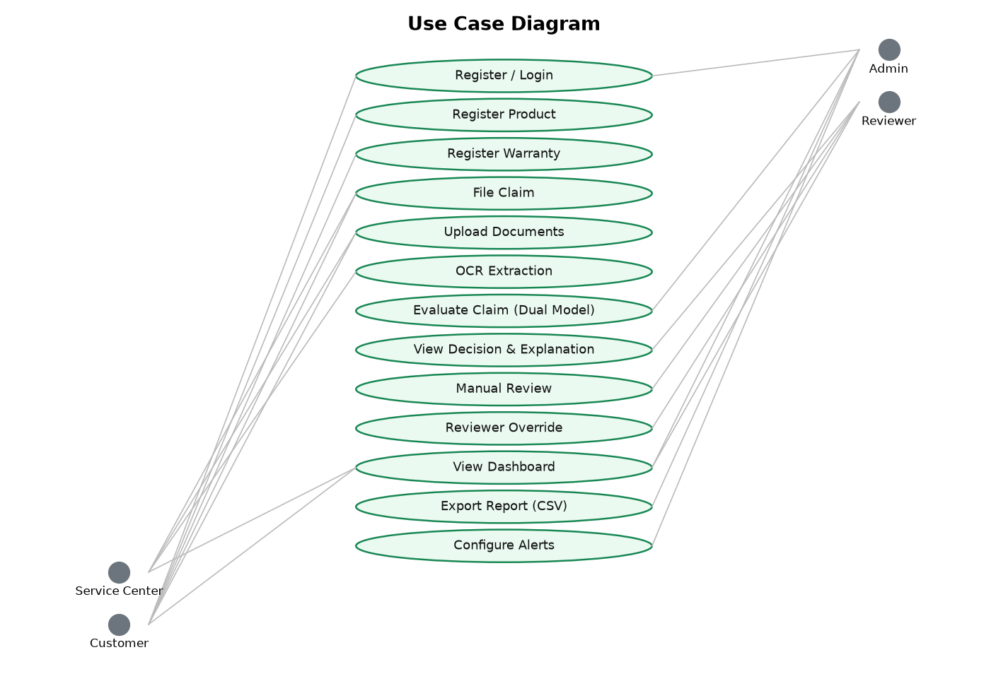
Usecase

16. Activity Diagram
The activity diagram traces the claim lifecycle from login through product selection, fault entry, document upload, OCR, verification, rule evaluation, dual-model scoring and the final decision branching into Likely Valid, Manual Review Required or Likely Invalid.
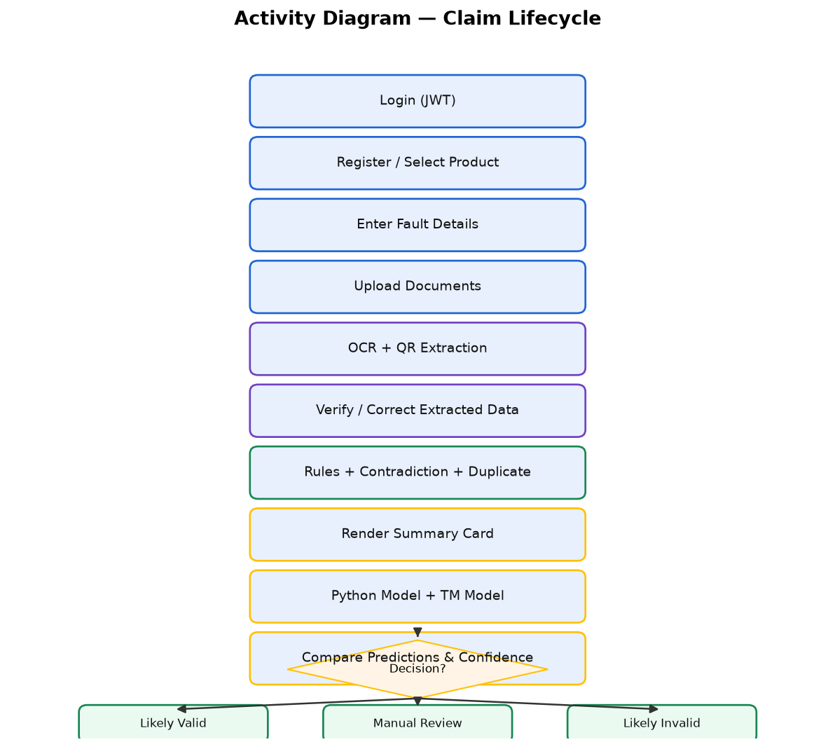
Activity

17. Sequence Diagram
The sequence diagram shows the interaction between the user, the frontend, the FastAPI backend, the OCR/rules layer, the ML service and MySQL during a claim evaluation.
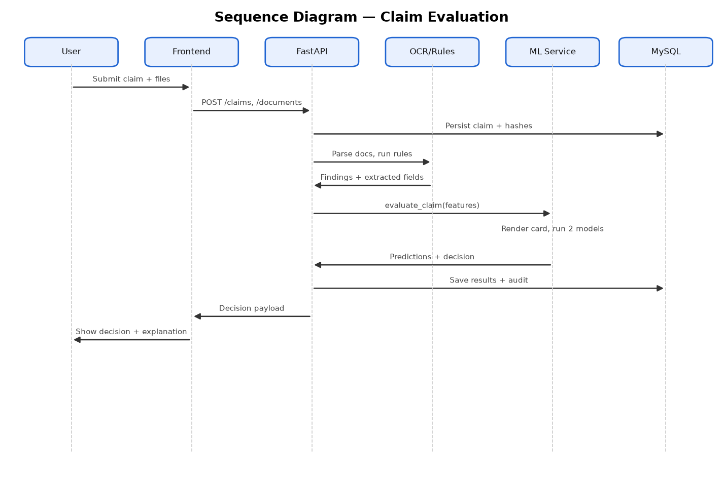
Sequence

18. Decision Flow Diagram
The decision flow diagram shows how the model outputs and rule findings are combined. Hard policy failures force Likely Invalid. Otherwise, if the models agree and the rules pass, the claim is Likely Valid. Low confidence, disagreement, contradictions, duplicates or missing documents route the claim to Manual Review Required.
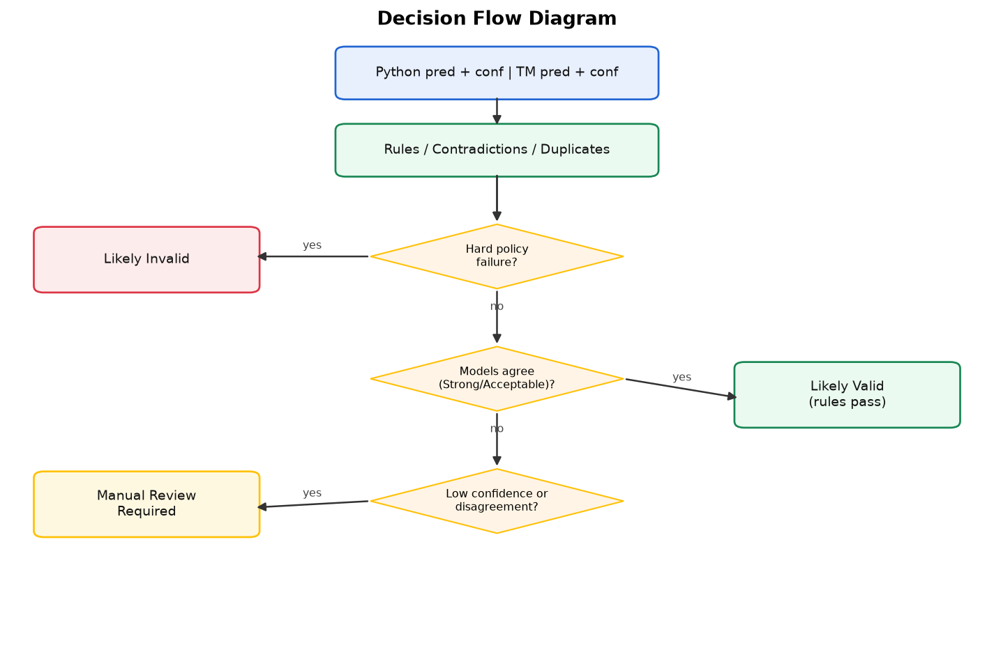
Decision Flow

19. Rule-Engine Design
The rule engine is policy-driven. Each product category maps to a JSON policy file that defines the default warranty duration, covered and excluded fault types, mandatory documents, reporting period, maximum repair history and whether authorized service centres are required. For a given claim the engine checks: warranty validity (remaining months or expiry date plus grace period); excluded damage; missing mandatory documents; unauthorized repairs; excessive repair history; late reporting beyond the reporting window; proof-of-purchase presence; prior replacement; and extended-warranty validity. It returns a structured result with passed/failed rules and a findings dictionary. Hard failures (expired warranty, excluded damage) force a Likely Invalid outcome regardless of the model outputs, while softer issues route the claim to manual review.

20. Python Classification Model Design
The Python model is a scikit-learn pipeline that combines preprocessing and classification into a single serialisable artefact. Numeric features are standardised and categorical features are one-hot encoded. The target is the three-class label. The numeric features are product age, warranty duration, remaining warranty months, purchase price, repair history count, unauthorized repair flag, serial-number match, receipt/warranty-card/damage-photo/serial-photo attachment flags, and contradiction and duplicate flags; the categorical features are product category and fault type. The model returns a class and a probability for each class; confidence is the probability of the winning class. Keeping preprocessing inside the pipeline guarantees that training and serving apply identical transformations.

21. Google Teachable Machine Model Design
The image model classifies the rendered Claim Summary Card into the same three classes. Cards are organised into class folders and used to train a convolutional network in the Google Teachable Machine workflow and exported in a standard format (Keras/TensorFlow Lite) with a labels file that fixes the class order. Images are resized to a fixed resolution, mildly augmented with small rotations and subtle brightness/contrast jitter, and normalised. Horizontal flipping is deliberately avoided because the cards contain text. A ResNet18 transfer-learning backbone is provided as an alternative. The exported model expects a three-channel image and returns a softmax probability per class.

22. Dataset Description
No public warranty-claim dataset exists, so a synthetic corpus was created. It contains 150,000 claims split evenly across the three classes (50,000 Valid, 50,000 Invalid, 50,000 Manual Review), divided into a stratified 70/15/15 train-validation-test split (105,000 / 22,500 / 22,500). Each record carries product, warranty, fault, document and derived features. From the same records, 30,000 Claim Summary Card images were rendered for the image model, balanced across the three classes and the three splits. The dataset deliberately excludes any prediction or decision columns to prevent leakage, and a validation step checks class balance, date consistency and the absence of leakage columns before the dataset is accepted.
Property | Value
Total claims | 150,000
Class balance | 50,000 / 50,000 / 50,000
Split | 105,000 train / 22,500 validation / 22,500 test
Summary cards | 30,000 PNG (2 variations per rendered claim)
Scenarios | 40 templates (12 valid, 12 invalid, 16 manual review)
Target column | label

23. Dataset-Generation Method
The dataset is generated by a seeded, reproducible pipeline. Forty scenario templates define the three families of claims. A generator combines each scenario with a product catalogue, randomised brands, models, retailers, purchase channels, prices and warranty durations to build a record. Dates are computed so that purchase, fault and claim dates are consistent, except where a contradiction scenario intentionally violates them. Document availability, serial match, repair history, duplicate and contradiction flags are derived from the scenario. The generator then shuffles records and reassigns sequential claim identifiers. A separate step produces a stratified split, a card-rendering step converts records into summary cards, and a validation step writes a PASS/FAIL report with class counts, scenario counts and image counts.

24. Data Preprocessing and Feature Engineering
- Handling missing values: optional fields default to safe values; required fields are validated.
- Date conversion: purchase, fault and claim dates are normalised to ISO format and used to derive product age, remaining warranty months and reporting lag.
- Categorical encoding: product category and fault type are one-hot encoded with unknown categories ignored.
- Numeric normalisation: numeric features are standardised with a fitted scaler.
- Derived features: product age, remaining warranty period, missing-document count, contradiction flag and duplicate flag.
- Document features: binary flags for receipt, warranty card, damage photo and serial photo; serial-match flag from OCR/QR.
- Card features: the same facts are rendered into the summary card so the image model sees the same information.

25. Python Model-Training Procedure
Training reads the processed train and test CSVs. A 15 percent stratified slice of the training set is used for model selection, then the winning model is retrained on the full training set and evaluated on the held-out test set. The pipeline is saved with joblib and its metrics and confusion matrix are written to a metrics file; a model-version row is recorded in MySQL. At inference the model is loaded once and cached.

26. Google Teachable Machine Training Procedure
The image model is trained on the rendered summary cards. Images are resized, mildly augmented and normalised. The network is trained with a cross-entropy loss and an adaptive optimiser, with the best validation weights retained. The trained model is exported in the Teachable Machine format together with a labels file. A ResNet18 transfer-learning variant is also supported. Because training on a CPU-only machine is slow, a stratified subset was used for fast iteration while the full dataset remains available.

27. Model Evaluation
Both models are evaluated on the held-out test split using accuracy, precision, recall and F1-score, together with a confusion matrix. The manual-review class is the hardest because it is designed to sit between valid and invalid. The dual-model comparison is evaluated through the match statuses (Strong/Acceptable/Weak Match, Model Disagreement, Uncertain Result).
Model | Type | Test accuracy
Python tabular | Random Forest (scikit-learn) | 96.3%
Google Teachable Machine | CNN (Keras, TM format) | ~96.1%
ResNet18 (fallback) | PyTorch transfer learning | 94.7% (full) / 86.7% (fast subset)

28. Confusion Matrix
The confusion matrix for the Python tabular model on the test split is shown below. Rows are the actual classes and columns the predicted classes, in the order Invalid, Manual_Review, Valid. The matrix shows near-perfect separation for Invalid and Valid, with the small remaining errors concentrated in the Manual_Review class, as expected.
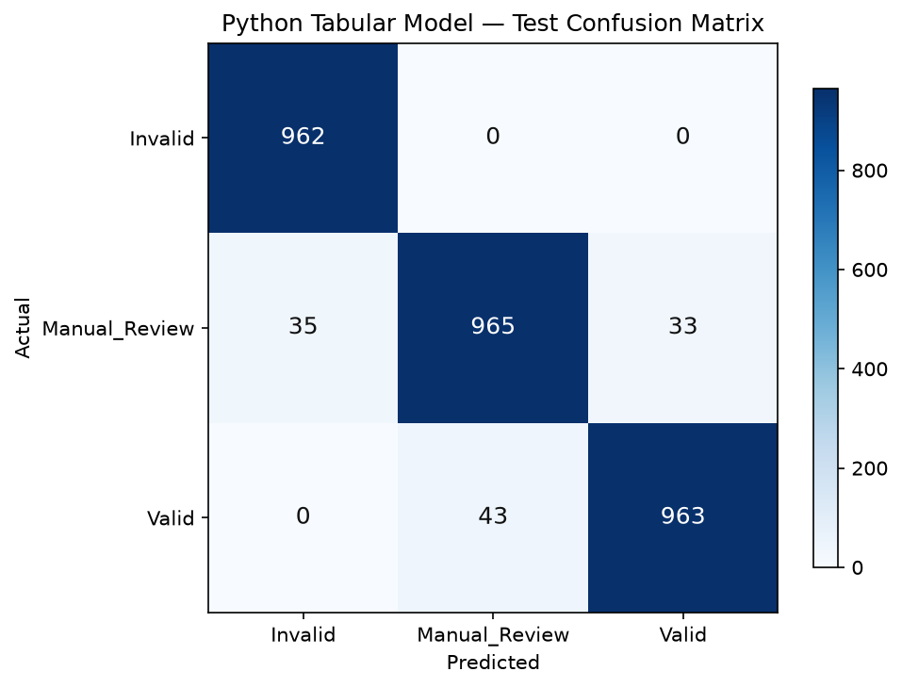
Confusion

29. Accuracy, Precision, Recall and F1-Score
Metric | Value | Interpretation
Accuracy | 0.9630 | Correct predictions across all three classes
Precision (weighted) | 0.9630 | Low false positives
Recall (weighted) | 0.9630 | Low false negatives
F1-score (weighted) | 0.9628 | Balanced precision and recall

Per-class figures: Invalid precision 0.96, recall 1.00, F1 0.98; Manual_Review precision 0.96, recall 0.93, F1 0.95; Valid precision 0.97, recall 0.96, F1 0.96.

30. Model Prediction and Confidence Comparison
After both models classify the claim, the system compares the predicted classes and the confidence scores. The absolute difference between the two top-class confidences determines the match status using configurable thresholds: a difference of at most 0.10 is a Strong Match, up to 0.20 is an Acceptable Match, and larger differences are a Weak Match; a top confidence below 0.60 is an Uncertain Result; differing classes are a Model Disagreement. The final decision combines this comparison with the rule findings. Model disagreement, low confidence, contradictions, duplicates or missing documents route the claim to manual review rather than forcing a decision.

31. Testing Strategy
Testing is performed at several levels. Unit tests cover the rule engine, the contradiction checker, the duplicate detector and the decision engine, including boundary cases such as a remaining warranty of exactly zero, a claim filed on the purchase date, and every confidence threshold. Integration smoke tests exercise the API end to end: health check, logins for each role, product creation, claim creation, document upload with SHA-256 verification, dual-model evaluation, persistence, reviewer override, audit log, analytics and CSV export. The frontend build is verified with a production build, and manual testing follows a checklist covering all roles and the full claim wizard. Confusion matrices and per-class metrics are reviewed after each model training run.
Level | What is tested
Unit | Rule engine, contradictions, duplicates, decision engine, thresholds, policies
Integration | REST endpoints, uploads, evaluation, override, audit, analytics, export
Model | Accuracy, precision, recall, F1, confusion matrix
UI | Wizard flow, dashboards, reviewer queue, responsive layout
Manual | Role-based end-to-end scenarios and boundary cases

32. Security Considerations
Security is enforced at multiple layers. Passwords are hashed with pbkdf2_sha256 and never stored or logged in plain text. Authentication uses JWT (HS256) with an expiry, and every route is protected by role-based access control. Uploads are restricted by an extension whitelist and a 10 MB size limit, and file names are sanitised to prevent path traversal. Document duplicate detection uses SHA-256 hashing. The API returns generic error messages so internal details are not leaked, and an audit trail records every critical action. Model versions are tracked so that historical predictions remain reproducible.

33. Privacy Considerations
Claims contain personal and financial information such as names, emails, addresses, receipts and photographs. Access is limited by role so that customers see only their own claims. Extracted document text and images are stored on the server and referenced by the database. The training dataset is fully synthetic and contains no real customer data. For a production deployment, uploaded evidence should be served only through authenticated endpoints, retention periods should be defined, and consent and data-minimisation principles should be applied.

34. Limitations
The current system has several limitations. The dataset is synthetic, so reported accuracies should not be taken as real-world guarantees. The image model classifies rendered summary cards rather than raw damage photographs. OCR accuracy depends on image quality and cannot recover unreadable text. Training and inference were performed on CPU-only hardware, which limited model size and training time. The confidence scores are not calibrated, and the rules engine depends on policy files being kept up to date. Finally, an early version of the dataset suffered from label leakage through the claim identifier, which was identified and corrected by removing the identifier from the summary cards and retraining.

35. Future Enhancements
- Train on real, anonymised warranty-claim data to validate real-world accuracy.
- Calibrate confidence scores and add per-class thresholds.
- Classify raw damage photographs directly instead of rendered summary cards.
- Add active learning so reviewer decisions feed back into model retraining.
- Introduce a proper model registry with automated retraining and data versioning.
- Add a mobile application and multi-language support.
- Integrate with external ERP/CRM systems and payment providers.
- Add explainable-AI visualisations (for example feature attribution) to the claim page.

